Freelance Contract: Assistant Project Coordinator, Cultural Connectors
July 2022

Timescale: September 2022 – August 2023
Fee: £3,150 – based on 18 days @ £175 p/d, inclusive of VAT and expenses
Deadline: Friday 19 August 2022, 5pm
Interviews: Thursday 25 – Friday 26 August 2022 (virtual or in-person, Southampton)
FREELANCE BRIEF

We are seeking a contractor to join the Connecting Culture Research Project team as a freelance Assistant Project Coordinator, responsible for supporting the Lead Project Coordinator and Project Leadership Team, in the smooth running and safe delivery of the Cultural Connectors young people’s programme of creative research traineeships and cultural leadership development.

This is a role where you can make a real difference to the lives of young people across Southampton. Working with our cohort of Cultural Connectors, a variety of project partners, artists and specialists, the Assistant Project Coordinator will provide workshop and facilitation support, administration and coordination over the 12-month programme, including, monitoring and evaluation data gathering, and supporting organisational tasks around events as required.

BACKGROUND

About Connecting Culture Research Project

Connecting Culture is a research project led by University of Southampton’s Arts and Culture Team and supported by a £75,000 Project Grant from Arts Council England. With a large consortium of cultural organisations and child-focused services as project partners, the research explores the question of how Southampton’s thriving Cultural Quarter can enrich the lives of children and young people as a future creative hub.

The aim is to enable young people to produce a ‘Young People’s Manifesto and Map’ to be adopted by Southampton City Council’s ‘Child-Friendly Southampton’ policy and to create a sustained programme that reflects their needs. This project aligns with major developments in the city such as Southampton’s UK City of Culture bid and Southampton’s UNICEF Child Friendly City programme. We have completed a city-wide Creative Consultation with 600 children, aged 5 to 18, to understand their experiences of culture and their ambitions for a creative Southampton.

This large and ambitious pilot programme will serve as a new model of cross-sector working for Southampton, leading to a step-change in how the city engages with children and young people by directly drawing on their real-life experiences to shape future actions and activities – the first ‘place-based’ case study of a city in the UK.
For information: connectingculture-southampton.org.uk

The Cultural Connectors

Ten young people aged 16-25 years will be recruited to the project as ‘Cultural Connectors’: a dynamic creative research traineeship and cultural leadership programme.
The Cultural Connectors will explore the cultural activity of children and young people and their ambitions for a ‘creative Southampton’, working with the research team to:
- Co-design and undertake research into the activity of children and young people in the city
- Develop a Young People’s Manifesto and Map for Southampton
- Co-develop and deliver a communications plan focused on children and young people
- Co-create commissions and public events with our Consortium partners

To support their creative traineeship, the Cultural Connectors will undertake training and be mentored. Training will include research and evaluation, Arts Award Advisor (Discover and Explore) training for 18+, workshop facilitation, creative programming, and event management. Their traineeships will be underpinned by the Arts Award programme and participants will work towards achieving their Gold Arts Award.
The Cultural Connectors will be involved in inter-regional peer-exchanges, visits, and dialogues with other young people’s initiatives. Where possible, we will work with young creatives to deliver training to the Cultural Connectors, acting as role-models and inspiring youth leadership within the group.
Further information: connectingculture-southampton.org.uk/cultural-connectors
ABOUT THIS ROLE & CONTRACT

We are seeking a freelance Assistant Project Coordinator to join our team, to support the smooth running of the Cultural Connectors young people’s programme. You will work closely with the Lead Project Coordinator to support the coordination and delivery of planned events, tasks and workshops.

You will need to be flexible, able to plan and think on your feet. You will have a passion for creativity and be a champion for young people and youth arts. You will have some experience of workshop delivery and pastoral care with young people.

You will be offered mentoring, training, and support as part of the contract, so that you too will be able to develop your leadership skills over the lifespan of the project.

This contractor will be supporting in-person workshops, taking place in Southampton over a 12-month period. The ability to work in-person in Southampton is essential with evening and weekend work will be required.

We anticipate sessions taking place on one weekend evening (Tuesdays) and one weekend day, fortnightly, exact days will be determined by the availability of the young people, and is subject to change.

OBJECTIVES
To play a key part in the successful delivery of the Cultural Connectors young people’s programme, supporting the Lead Project Coordinator and Project Leadership Team.

This has the following aims:
- To explore the question of how Southampton’s thriving Cultural Quarter can enrich the lives of children and young people as a future creative hub.
- To co-design creative opportunities with, led by and for young people in Southampton
- To nurture a cohort of young people who are representative of Southampton’s communities as cultural leaders.
- To increase awareness of, and participation in, creative activities for children and young people in the city.

This will involve:
- Assisting the Lead Project Coordinator in project’s planning and delivery, supporting the workshop elements of the Cultural Connectors programme.
- Working with the Project leads and Cultural Connectors cohort to recruit appropriate artists and creative practitioners to enable and facilitate elements of the programme.
- Supporting the delivery of effective promotion of the programme on offer to other young people across Southampton, utilising all appropriate channels of communication e.g. the full range of digital media, school visits, press coverage etc.
- Supporting and attending workshop sessions and programme elements, providing support to the Cultural Connectors, visiting artists and participants.
- Ensuring the smooth running of activity within the programme as agreed e.g. training courses, visits to cultural venues and networking opportunities, liaising with project partners and other youth leadership projects in the region.
- Ensuring that policies and values are enacted in all projects e.g. safeguarding, child protection, health and safety, risk assessment etc.
- Administrating Arts Awards training and moderations as needed, and acting as an Arts Awards adviser to young people undertaking the accreditation.
- Contributing to monitoring and evaluation of activity, keeping up to date records of numbers of participants, geographical data, consent forms etc.
- Contributing to reporting on the progress, impacts and achievements of the project for the steering group, funders and Southampton Cultural Education Partnership
- Providing support to the research process e.g. interviews, focus groups.
- Contribute to compliance with Policies and Procedures as appropriate, including: procurement (UoS), GDPR (UoS), Confidentiality (UoS), Safeguarding and Child Protection (UoS), Equality, Diversity and Inclusion (UoS).

The Assistant Project Coordinator is required to demonstrate the following:
This is an entry level cultural coordination job, with a focus on supporting young people’s experience of engaging with the workshop elements of the project. While we know you may not have lots of experience, we are looking for someone with competent organisational skills, with a passion for empowering young people to engender change in their lives and wider community, especially in the areas of youth voice, cultural development and reaching marginal communities. You will work closely with the Lead Project Coordinator/Management Team to ensure the project aims are met to the highest standard possible, and address concerns that arise in the ongoing delivery of the Cultural Connectors programme.
Essential experience, skills and qualities:

- Excellent organisational and time management skills.
- Attention to detail and good written communication skills.
- Some experience of facilitating workshops or sessions with young people.
- Efficient, accurate administrative skills, in particular computer skills (MS Office and Mac) and virtual meeting platforms e.g. MS Teams.
- Understanding of current best practice in Equality, Diversity and Inclusion.
- Experience in or enthusiasm for applied creative arts (in any medium). Experience of developing positive working relationships with communities, artists and/or young people.
- Excellent interpersonal skills. Confident communicator with the ability to relate to a wide range of people.
- Ability to problem solve and develop creative solutions to challenge.
- Ability to relate to and work with young people especially those with complex needs.
- Up to date awareness of best practice in Child protection and safeguarding. (Note: further training will be offered.)
- Familiarity with Southampton.
- An up-to-date enhanced DBS (Disclosure & Baring) check or willingness to complete an enhanced DBS check

Desirable skills and experience:
- Knowledge of the cultural life of Southampton, and local communities. Experience of promoting and marketing youth arts activities and ability to identify creatively about marketing opportunities.
- A driving licence.
- Arts or community project management experience.
- Youth work experience and an informed knowledge of best practice in youth arts.
- Experience of working with interns and volunteers.
- Experience of youth voice consultations.
- Arts Awards Adviser trained. (You will be offered training if not.)

HOW TO APPLY
The University of Southampton’s Equality, Diversity and Inclusion mission is to create an inclusive university community. We particularly encourage responses to this opportunity from professionals who are underrepresented in the cultural and education sectors.

To apply for this contract, please supply:
- Why you want to work as the Assistant Project Coordinator and what motivates you to do so.
- A response to the brief
- Your CV
- Details of previous relevant work/experience
- Names and contact details of two referees with knowledge of your work in a similar capacity
- Details of professional indemnity and public liability insurance, and an Enhanced DBS.
Application Deadline: Friday 19 August 2022, 5pm
Please email your response with subject ‘Assistant Project Coordinator’ to Connectingculture@soton.ac.uk

Interviews will be held between Thursday 25 – Friday 26 August 2022 either in person at a central Southampton venue or via TEAMS.

ACCESS SUPPORT AND GENERAL ENQUIRIES
We want to ensure the application process is accessible, and to give everyone the information they need. If you require this document or any further information in a different format, or have questions before you apply, please get in touch by email to Connectingculture@soton.ac.uk and provide a contact telephone number.

For further information about the Connecting Culture project visit:
connectingculture-southampton.org.uk

Connecting Culture is generously supported by

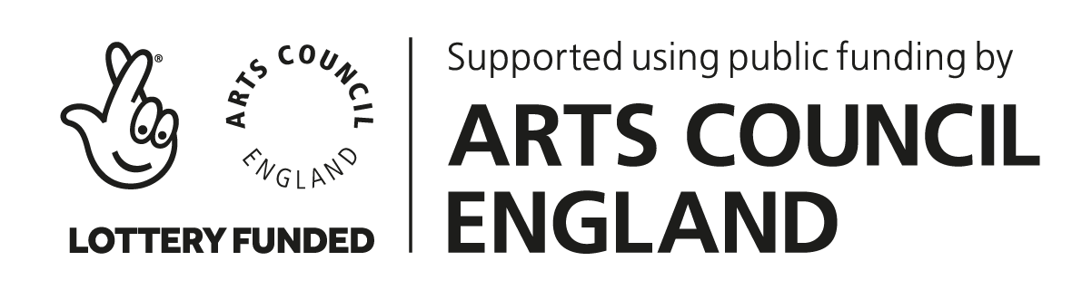

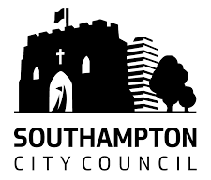

Connecting Culture is proud to support

